Recreational Pilot e-zine

Issue 83
June 2014

From the President
Rodger Ward/RAANZ Pres

Hi,
I thought I might give a very brief introduction into the workings of RAANZ.

RAANZ is an incorporated society where one of the aims is to ‘To provide an organisational structure to liaise with the regulatory bodies governing recreational flying, to accept delegated responsibilities from these bodies, to discuss and promote all aspects of the sport of Recreational Flying and the use of Recreational Aircraft with these bodies’.

As a means to assist in achieving this aim we have been delegated approval from CAA under rule Part 149 to issue microlight pilot certificates. This issuing is done under the supervision of key personnel who are appointed by the RAANZ executive and become an integral part of it. These key personnel have significant authority under Part 149 and are subject to a far more stringent ‘Fit and proper person test ‘ than the general membership.

A key element in our Part 149 delegation is our CAA approved Policy and Procedures Manual. This is a significant document that details to CAA how we will do what we need to do to comply with the appropriate rules. This document has evolved over the years and has been kept as simple as it can be. Please do not be tempted to abbreviate any of the steps or processes involved.

It will be obvious that the ‘microlight’ definition has been well and truly stretched over the years and it is a credit to all involved that this has occurred in a very professional manner. Saying that, it is extremely important that we do not relax, become complacent or take our finger off the trigger.

Did you know
- The sky does have edges or at least a top and bottom edge.
- At the top edge the air becomes very thin. Aeroplanes and people do not perform very well.
- At the bottom edge there are hard things and if aeroplanes make contact with them inappropriately a lot of damage and misery can be created.
- Be very careful when operating near the edges!!

Continuing on from last month’s report on the ‘Frank Bailey Mustang” is an interesting report on an aircraft from middle of the microlight spectrum. The Rans S6.

The RANS S6
Easwaran Krishnaswamy (aka Iceman)/Rangiora

In my little time of flying planes in New Zealand I have had the opportunity to fly a few different types of these contraptions that seem to challenge, as Sir Isaac Newton called it, ‘Gravity’. These are my thoughts and views and I’m sure the very perceptive of you would have noticed the title at the top, yes! About the RANS S6 aircraft/microlight/ultralight/rag and tube and the many other names it is known by.

I am definitely not trying to sell you anything that you don’t need. I do understand there is a preconception among most GA pilots that microlights are ‘dark side’ that fly on lawnmower engines and are not real airplanes, but the laws of physics don’t seem to change and most 3-axis microlights fly using the same principles that real airplanes use to fly with.

Who am I? I am Easwaran Krishnaswamy, a RAANZ executive member and a Senior Instructor with the Canterbury Recreational Aircraft Club at Rangiora. But for those of you that have a hard time saying my name most of locals here call me ‘ICEMAN’. I am also a Multi-engine Instrument rated Commercial Pilot who’s “embraced the dark side” in a manner of speaking.

The Club has recently upgraded to Top of the line $110,000 Tecnam ECHO Classic with an 80HP Rotax 912. Giovanni Nustrini, the Tecnam man himself, flew the plane down to deliver it and we did a check flight for the handover. It is fair to say I hadn’t flown that type configuration before. We were lined up for take-off from RWY 07 at Rangiora and I smoothly powered up with the Rotax purring away on the take-off roll and climbing out I hear Giovanni’s voice “Finally someone that flies with the ball in the middle”. Some of this could be attributed to the aircraft which this article is waffling on about. I have spent a fair chunk of my time in the RANS S6 flying it, not so much now. I let my students do all the work and just enjoy the view.
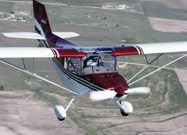
I got into RANS S6 flying after working for Brent Thompson making aircraft propellers and I’m sure most of you that know Senior Instructor Brent, know that he’s a perfectionist and a craftsman. I should give due credit to all the fine Instructors that have taught me how to fly and also the dark art of microlight flying.

If you have ever received any dual flight instruction from me you would know that, trained as a commercial pilot, I’m very hard to please. Some people would say I have a high standard of expectation and when you reach the standard I raise the bar some more just to keep the game challenging. I believe in being a perfect pilot but I know nobody is perfect so we try and strive towards perfection.

If I say that learning to fly in the Club RANS S6 was a pleasurable experience I would be lying because it was noisy, draughts everywhere and with the vibrations of a two stroke howling in front without the comfort of ANR headsets, it was pretty loud and rackety and she was a bit of a handful.

Then something happened- I started listening to what she was telling me.

The adverse yaw that kicks in told me to use my feet and the draught through the side door gaps told me I’m not flying in balance. The little bumps she makes with the flaps out if you are getting too fast or how she won’t budge if you kick her around and do her own thing. It’s like all the theory that you learn in principles of flight stare at you and show you how they work in action. I have a saying I tell some of my students as an analogy, I’m not being a male chauvinist in anyway, “Treat her like a lady. Listen to what she wants and give it to her and she will listen to you”. In a way every Aircraft has its own personality and it’s like getting to know someone by going on a few dates namely “a type rating”.

An airplane that truly makes you work those things by your feet that some pilots think are foot rests, the rudder pedals. I’m sure there is a reason the Wright brothers invented them. A middle of the road honest aircraft that once you have got the hang of would probably make a transition into a high performance microlight e.g. a Tecnam pretty straight forward and similarly going low performance e.g. a Bantam pretty easy too.

They always talk to you, you just have to listen. When we stop learning and bettering ourselves it’s like we’ve stopped living. Fly safe with love for the love of aviation.

Cheers ICEMAN

The great RAANZ trophy hunt
Ken McKee/Napier

RAANZ has been donated a total of five trophies by generous people over many years.

Traditionally these trophies have been presented to the winners of various competitions at the annual RAANZ National Rallies, to be held by them until the next rally.

All the trophies were ‘missing’ for a number years. After much searching, four of the trophies have been found and are now to be held by the Central Hawkes Bay Aero Club, where the next rally will be held. Sadly the trophies have all sustained damage while being held by different members, or being transported over the years. At some cost, the recovered trophies are being restored to good condition.

Also there have been problems keeping track of the trophies.

If transport and tracking of the trophies is to be avoided they need to be kept in a known and secure central location.

It has been suggested that future rallies are held in a suitable, central location, where the trophies can be held in trust and be on display. The Trophies could then be presented in the usual tradition and immediately retrieved to be displayed safely until the next rally. At the same time the recipients would be presented with a suitable trophy to keep.

RAANZ Executive are presently considering what to do about the situation.

Meanwhile can any member please help in tracking down the following missing trophy:
- TECNAM TROPHY - a mounted model of Tecnam Echo KMA, colour Yellow and black.
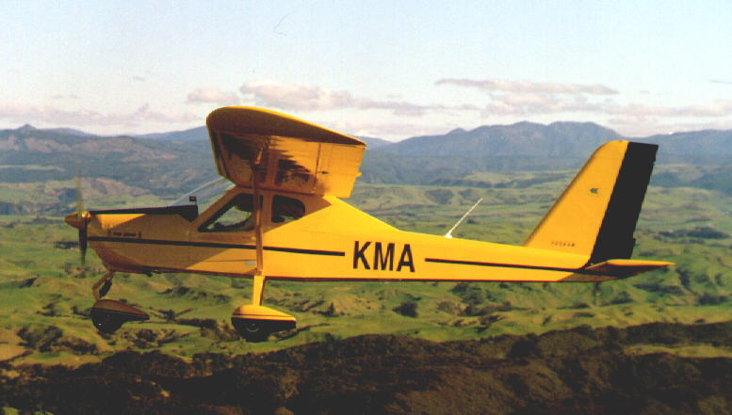
If you have any info about this trophy please contact Ken McKee, phone 06 843 0327.

Flying in cloud, continued...
Brian Mackie, Tecnam Sierra ZK-KFA
The first time I went into a cloud without a clue was around 1985, over the coast of northern France, in a TB10. I had a basic PPL at the time. We were en route for lunch from Biggin Hill to Deauville, just south of Le Touquet, I flew the aeroplane into a large and very high bank of sea fog.
Within 30 seconds, the aeroplane was in a spiral dive at 1200 feet per minute. The three passengers had absolutely no idea what was going on, and remained completely relaxed throughout. At about 1500ft, perhaps less, we popped out and I noticed the washing hanging from seaside high-rise apartments in Burck sur Mer (at roughly a 180-degree angle from my seat). Thank God, there was room to stabilise the aircraft and sort ourselves out.
We diverted with Special VFR to Le Touquet and my innocent passengers did not notice me kissing the ground (while realising why certain Popes have been in the habit of doing likewise).
Any sane pilot wishing to collect the pension (and I was only about 35 at the time) sooner or later discovers that clouds can be killers. You'll get turbulence in them and you may also get carb icing. You enter the world of a wrestler's armpit, you swiftly won't have a clue what's going on, and you run a very high risk of missing lunch and buying the farm instead.
After the French incident, I immediately went for an IMC rating and then went on to the PPL IR.
But when it comes to IR currency, I am now three decades out of date - and although my current microlight aircraft has an artificial horizon and an autopilot, civil aviation rules governing VFR flight don't even figure in my personal policy. Which is simple: Never knowingly put yourself inside a cloud, and try to avoid being on top of them.
Forget for a moment the nightmare of being VFR on top without a hole to drop through. How will you handle the reality of being inside a cloud, and untrained in the magic arts of IFR?
When it starts to go pear-shaped, the first thing you will notice is a dramatic increase in engine noise and prop speed. Your brain will not tell you that you have put the aeroplane into an unusual attitude - and might well be upside down.
The only solution is to reduce engine speed to near-idle and take your hands and feet off the controls. Lean back, and pray for enough visible ground clearance to recover, because that is now your only hope.
It has been said that 90 seconds is roughly the time it takes to achieve spatial disorientation. Half a minute is more accurate. But what's a few seconds either way, compared to eternity?

Airways user survey- have your say
Erin Black/Airways NZ
We have received an expression of interest from Rodger Ward, for RAANZ members to be invited to participate in the current GA survey Airways is running.
The survey will take approximately 5 minutes to complete and will allow us to monitor overall performance for the past 12 months. The survey commenced on Thursday the 22nd of May and participants will have until Thursday the 12th of June 2014 to respond.
Responses will be gathered online and we would greatly appreciate if RAANZ could assist us in distributing the survey link to your members via email. An accompanying advisory containing a link to the survey has been attached in the following.
Kind regards,
Erin
Airways General Aviation (GA) Survey Email Advisory
Subject: Please tell us what you think, a chance to have your say with Airways

Airways is keen to learn more about your thoughts and experiences as General Aviators. From Thursday, the 22nd of May you have the opportunity to participate in the Airways GA Survey online.
Have your say on topics including Airways service performance, the IFIS website new look and feel, aviation apps and more. The survey is relatively short and should take approximately 5 minutes to complete. Please respond via the following link before the 12th of June to submit your feedback:
http://www.surveymonkey.com/s/558SZTP

What's new on the RAANZ website- Defect Reports
One finding from our last Part 149 annual audit was that our Defect Reporting system was not being used, and that we should update the system and actively encourage its use as a means of collecting and identifying significant issues, and disseminating important safety information to pilots.

To help encourage more use of the system, we have updated the Defect Report forms and page on our website. Go to http://raanz.org.nz/wiki/pmwiki.php?n=Tech.Defects where you will find a link to download a Defect Report form, and also see a listing of received Defect Reports against aircraft type.

The aim is that this page will be a valuable reference resource for aircraft owners and IAs – a heads-up on the common and not-so-common defects for teat type that others have found...so you won't have to find them.

This will only work if you contribute with your experiences. So... help save an incident, a plane, a life- use the system, file a report, read the reports.

Engine development- the AutoFlight 700cc twin

Neil Hintz of AutoFlight fame has been developing an 80HP water cooled 700cc twin 2-stroke engine for microlights. He has a running prototype which can be viewed on YouTube at https://www.youtube.com/watch?v=5DyPUqr4-CU

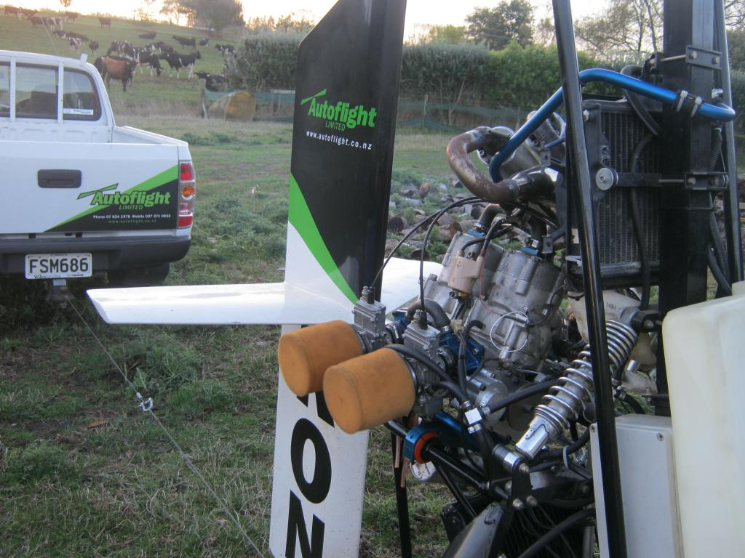
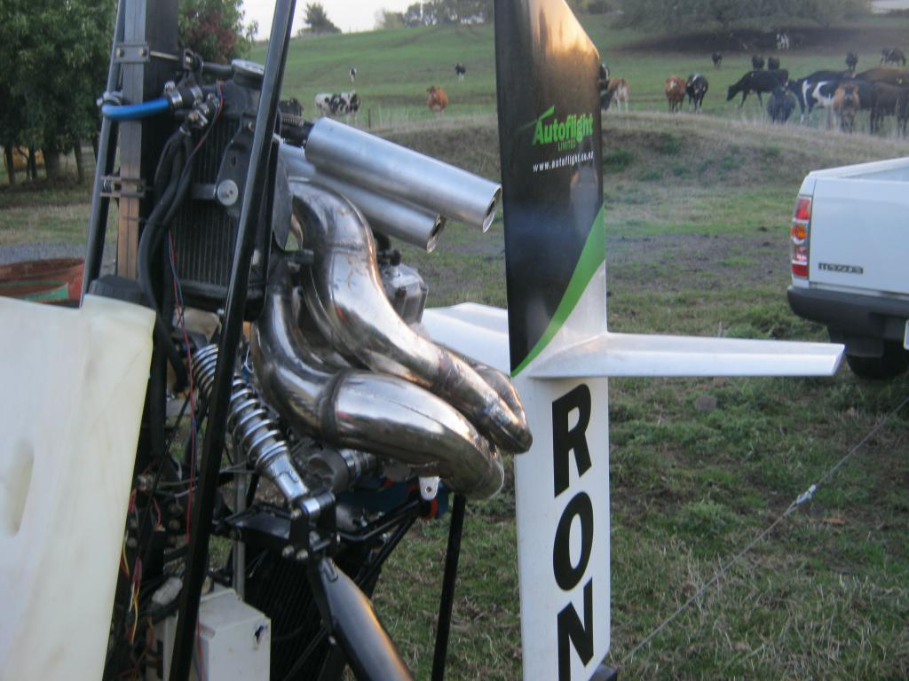
Neil is planning a small pre-production run and is looking for interested parties to help fund this run in return for a low cost engine (he estimates about $5-6K per engine).

Neil stresses that this is still in development/prototype phase, and participants need to understand there may be some back-tracks or modifications needed as more run-time experience is gained. But he is happy with progress and performance to date, and reckons he is on to a winner.

If you are interested, contact Neil at nckm@wave.co.nz , +64 25 271 0602 or +64 7 824 1978

Membership changes

© 2014 Recreational Aircraft Association of NZ Inc  PO Box 15-016  Dinsdale 3243  Hamilton | 07 825 2800  office@raanz.org.nz  w: www.raanz.org.nz | Not receiving this by email? SUBSCRIBE  Don't want to receive this any more? UNSUBSCRIBE  Want to contribute? CONTRIBUTE



